2636 Tibbets Dr, Bedford, TX 76022
Ph#: 817-809-4399
tiny2teenspedidental@gmail.com

From: Dr. _________________________________ Date: _________________________
Patient’s Name: ____________________________ Pt Ph#: ________________________

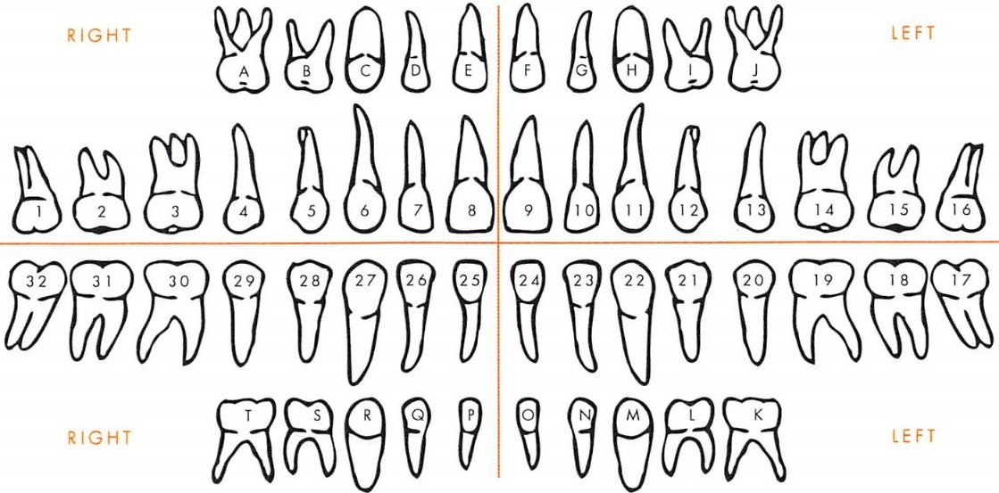

Special Instructions
____________________________________________________________________________________________________________________________________________________________________________________________________________________________________________________________________________

___________________________ ____________________
Doctor’s Signature Doctor’s Phone Number

